Packages:

**solarCalculations.klaus**: Offers two algorithms for calculation the position of the sun (as seen from earth)

**solarCalculations**: Offers methods for calculating Air Mass and Intensity (W/m²)

------------------------------------------------------------------------------------------------------------------------------------

Azimuth: Direction of the sun measured from North axis. Altitude CAN be measured from Azimuth.

ZenithAngle: The ZenithAngle, as used in the “solarCalculations.klaus”-Package, is measured from the Zenith. Therefore 0° would result in an Air Mass of 1 (optimal).

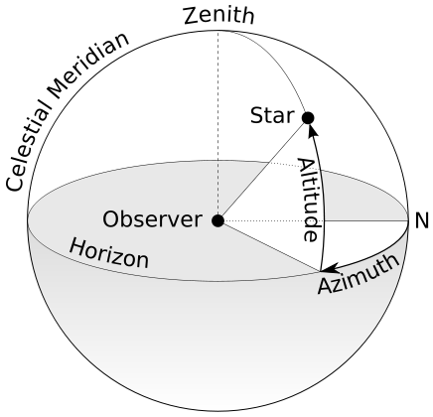

In August, the International Astronomical Union -- which you may remember as the body that [demoted poor Pluto to dwarf planet status in 2006](http://www.iau.org/public_press/news/detail/iau0603/) -- voted to fix the astronomical unit, which designates the distance between the sun and Earth, at 149,597,870.700 meters (92,955,807.273 miles). The new fixed distance replaces a complicated equation that served as the previous definition of an astronomical unit..

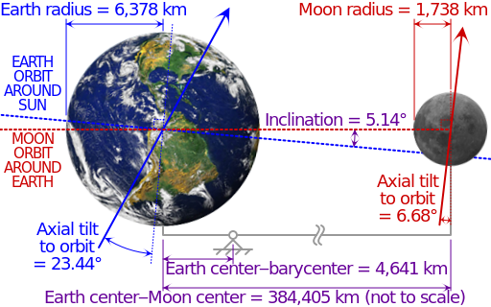

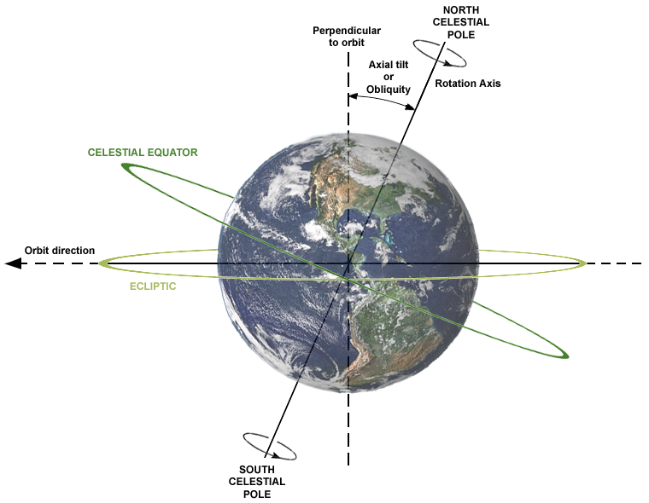

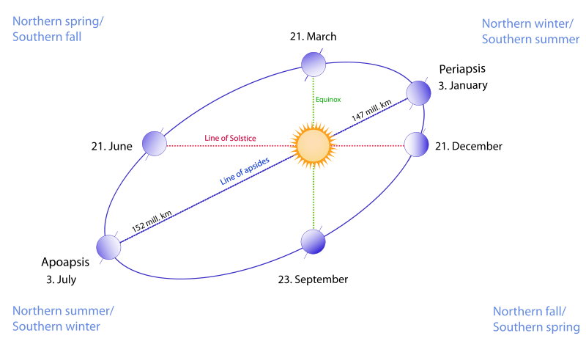

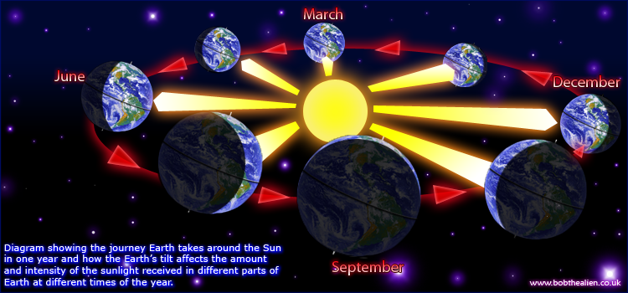

Speed of light: 299 792 458 m/s

365,256363004 days

~149 597 870,700 km

Earth:

R = 6 371,0 km (6 378,1 – 6 356,8)

510 072 000 km²

1,08321 * 10^12 km³

23,44°

Sun:

R =696 000 km +- 10/2km

1,4 * 10^18 m³ = 1,3 * 10^6 * EARTH